|  |
| --- |
| NCRWMS |
|  |
| Warehouse Management System |
|  |
|  |

**Copyright © 2012 Retalix Ltd.  
All rights reserved.**

**Israel**

10 Zarhin Street  
P.O. Box 2282  
Ra’anana 43000, Israel  
Tel.: +972 9 7766677  
Fax: +972 9 7400471  
Web site: http://www.retalix.com

**USA**

6100 Tennyson Parkway  
Suite 150, Plano, TX 75024 USA  
Tel.: +1 469 241 8400  
Web site: http://www.retalix.com

Retalix technical documentation and the product(s) described herein are protected by one or more U.S. copyrights, patents, foreign patents, or pending applications. No part of this publication may be reproduced or transmitted into any human or computer language in any form or by any means, stored in a retrieval system, transmitted, redistributed, translated or disclosed to third parties, or de-compiled in any way including, but not limited to, photoccopy, photograph, electronic, mechanical, magnetic or manual without the expressed written permission of Retalix Ltd., or its licensors, if any. All copies, so authorized, shall contain a full copy of this copyright notice.

Retalix products are licensed products. The product licenses convey the right to use only those specific products, components, modules, features and/or functions specified in the license agreement or contract. This publication may mention or reference products, components, modules, features and/or functions that are not part of a particular license agreement. The customer is not entitled to the receipt of, or use of, any other products, components, modules, features and/or functions that may be referenced in any documentation provided to customer unless additional license fees are paid and an appropriate license agreement is duly executed. Retalix’s obligations with respect to its products and services are governed solely by the agreements under which they are provided.

U.S. Government Users Restricted Rights: If the Customer is a United States Government entity, the Retalix products described herein are “commercial computer software” as defined by current Federal Acquisition Regulation (“FAR”), Department of Defense Federal Acquisition Regulation Supplement (“DFAR”), or other applicable Agency regulation provisions. If the Retalix products described herein are other than “commercial computer software,” then the United States Government Customer shall receive no greater than Restricted Rights, as defined in the currently applicable version of the FAR, DFAR, or other applicable Agency regulation. In the event that alternative regulatory rights allocation provisions are available to the parties, the provision which provides the Customer with the narrowest rights allocation permitted by law and regulation shall apply. For Civilian Agencies: Restricted Rights. Use, reproduction or disclosure is subject to restrictions set forth in subparagraph (a) through (d) of the Commercial Computer Software Restricted Rights clause at 52.227-19, as applicable, and the limitations set forth in standard Retalix license agreements for software and technical documentation.

This publication is furnished for informational use only and should not be construed as a commitment by Retalix. The information could include technical inaccuracies or typographical errors. Every effort has been made to make this publication as complete and accurate as possible, but it is provided “as is” without warranty of any kind either expressed or implied, including, but not limited to, the implied warranties of merchantability, fitness for a particular purpose, or non-infringement. Retalix may make improvements and/or changes in the program(s), product(s), and/or applications described in this publication at any time without notice. Due to continuous development of Retalix Ltd. products, information published in this document may become obsolete.

Third-party products, services, or company names referenced in this document may be trademarked or copyrighted by their respective owners, and are for identification purposes only.

Copyrights, trademarks and license agreements shall be governed and construed in accordance with the laws of the State of Texas and the Federal Arbitration Act, and shall benefit Retalix, its successors, and assigns.

**Revision History**

| **Date** | **Change** | **Document Version** | **Changed By** | **Approved By** |
| --- | --- | --- | --- | --- |
| 06/26/2014 | Original Document | 0.0 | Sanjay Sadanandan |  |
|  |  |  |  |  |

Table of Contents

About this document 6

Intended Audiences 6

Introduction …………..………..………….…………………………………………………….6

Installation and Configuration………………………………………………………………….7

Managing Retention Period…………………………………………………………………….15

Managing Job Type……………………………………………………………………………...16

Managing Log Level……………………………………………………………………………..16

# About this document

This document briefs you about the data archival strategy for RWMS.

## Intended Audiences

The intended audiences for this document are as follows:

RWMS DBA

## Current Scenario and Requirements

The amount of data determines the speed of query execution. With increasing amount of data, it becomes imperative to prune and maintain a small subset of data which will culminate in faster execution times for queries running against the RWMS database. The existing mechanism of archival and purging is outdated, clumsy and difficult to maintain. Thus there is a need to create a better strategy for maintaining a small subset of only required data for queries to run against.

## Prerequisites:

The user should have administrator access to the RWMS production database.

## Description :

The amount of data determines the speed of query execution. With increasing amount of data, it becomes imperative to prune and maintain a small subset of data which will culminate in faster execution times for queries running against the RWMS database. The existing mechanism of archival and purging is outdated, clumsy and difficult to maintain. The revamped archival and purging strategy is easy to maintain and allows easy tweak for configuration settings like retention period, job type and log level.

## Installation and Configuration :

The following items need to be in place for successful installation/implementation of Archival and Purging.

1. SQL Server 2008 Standard/Enterprise Edition on both Source and Target machines

>> Run the command on both machines and verify if they are same.

SELECT @@version;

2. Both Source and Target machines should be on the same domain

>> Run the command on both machines and verify if they are same.

SELECT DEFAULT_DOMAIN();

3. The Target machine should contain sufficient space to store the archive data.

>> Run the command at the Target

EXEC master..xp_fixeddrives;

From the result, make sure the drive on which the archive database resides has sufficient storage space to grow.

4. An identical SQL Server domain account login should exist on both Source and Target machines with

the db_owner database role on the RWMS and RWMS_SYS databases.

1.Right click on security tab-new-login

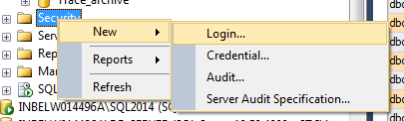

2.Use SQL authentication ,type the Loginname and password

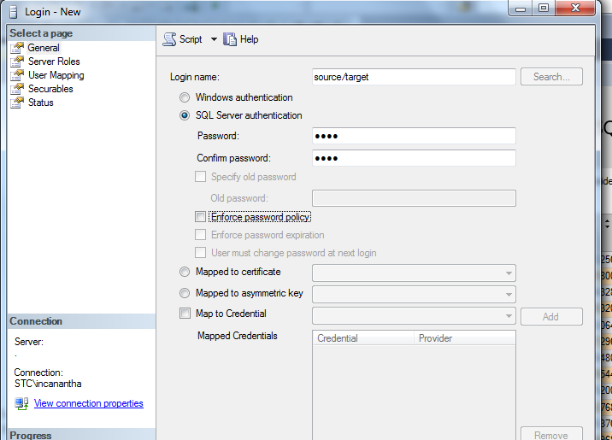

3.Go to User Mapping option and click on source/target db , provide the db_owner permission by checking the membership option.

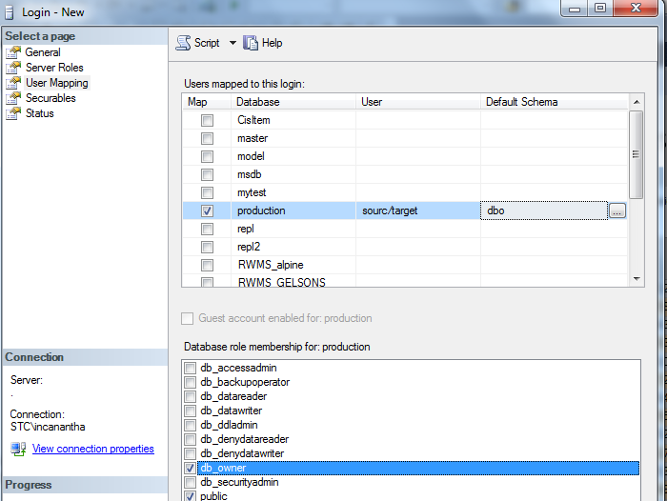

5. Distributed Transaction Coordinator (MSTDC) must be up and running on both Source and Target machines.

1. Go to the Run wizard and type, "services.msc"

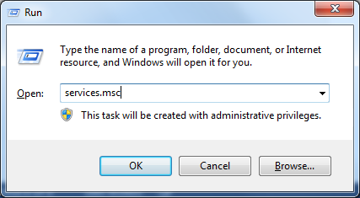

1. Click on "Distribution Transaction Coordinator" -> Start, if the service is stopped.

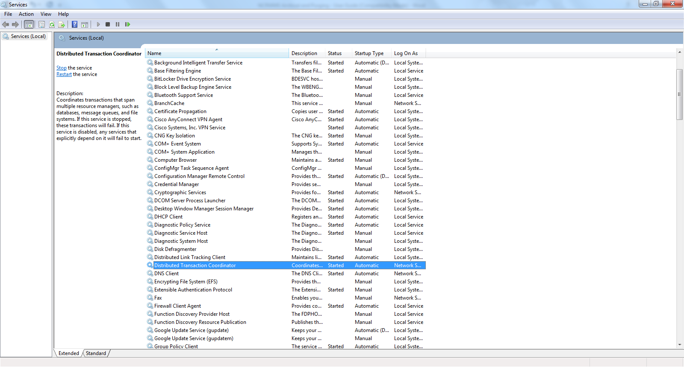

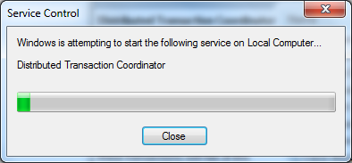

1. Go to the Run wizard and type, "control admintools"

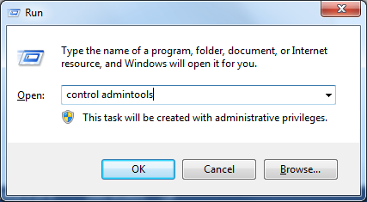

1. Double-click on "Component Services". Scroll down to Console Root -> Component Services -> Computers -> My Computer -> Distributed Transaction Coordinator. Select "Local DTC".

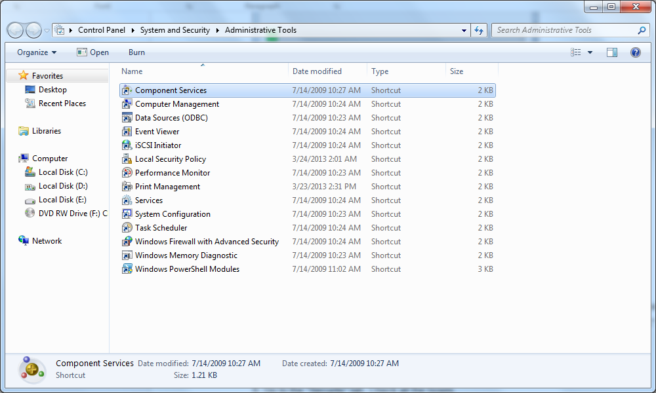

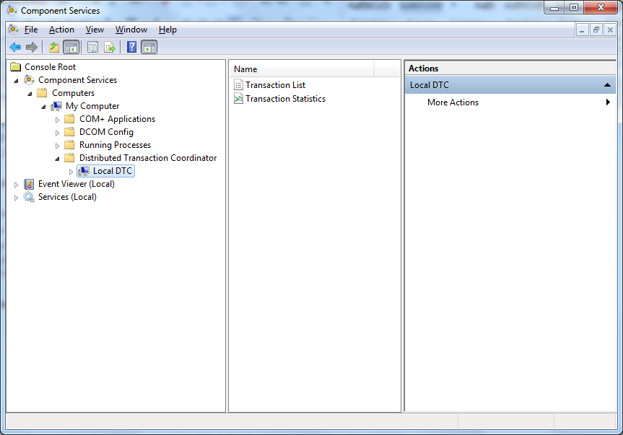

1. Right click on "Local DTC". Select "Properties"

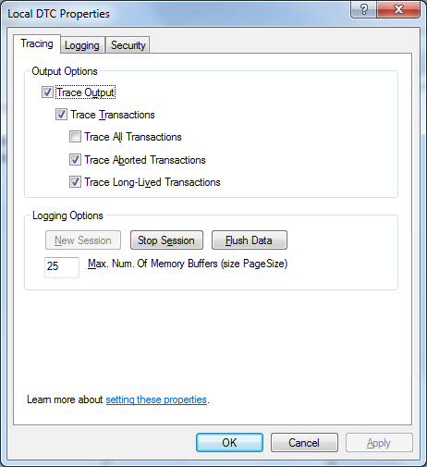

1. Go to the "Security" tab. Check all the boxes.

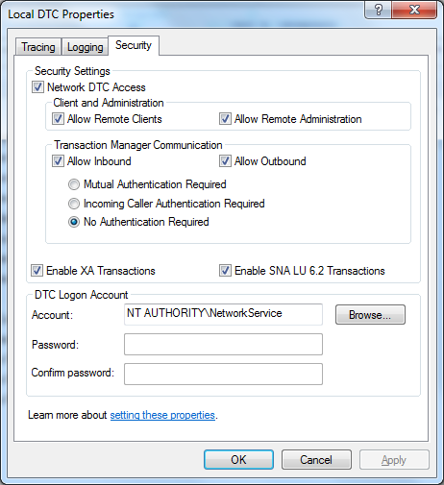

7. Select "No Authentication Required" radio button.

8. Make sure the DTC logon account runs under “NetworkService”.

6. The Target machine should contain an identical but empty RWMS database structure of the Source machine.

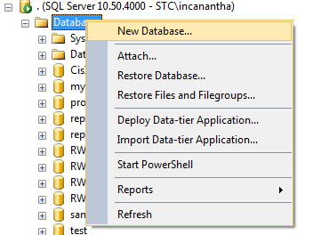

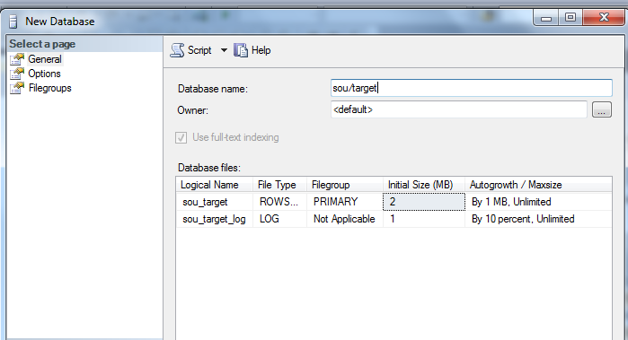

7. The SQL Server Agent service should be up and running on the Source machine. It is recommended to have a domain login account run the service.

## Managing Retention Period:

The retention period for individual tables can be tweaked to decrease/increase the number of days through the RWMS_ARCHIVAL_DETAIL table.

For example, to update the default retention period of 31 days to 99 days for a particular table, run the below command in SQL Server Management Studio.

Command :

UPDATE RWMS_SYS.dbo.RWMS_ARCHIVAL_DETAIL SET retention_period = 99 WHERE [PREFIX_CODE] = 'AUDIT';

## Managing Job Type:

Also, the job type ( A - Archival, P - Purging , B - Both ) can tweaked as well. See the example below.

Command :

UPDATE RWMS_SYS.dbo.RWMS_ARCHIVAL_DETAIL SET JOB_TYPE = 'A' WHERE [PREFIX_CODE] = 'AUDIT';

## Managing Log Level:

Similarly, the log level ( E - Error messages only , M - All informational, debug and error messages , D - Debug messages only ) can be tweaked at the table level as well. See below.

Command :

UPDATE RWMS_SYS.dbo.RWMS_ARCHIVAL_DETAIL SET LOGLEVEL = 'D' WHERE [PREFIX_CODE] = 'AUDIT';